CP212 Assignment 5 Documentation

Shawn Phung

200814180

**OVERVIEW**

This is the documentation for my Assignment 5. This includes screenshots, as well as explanations for how my code works.

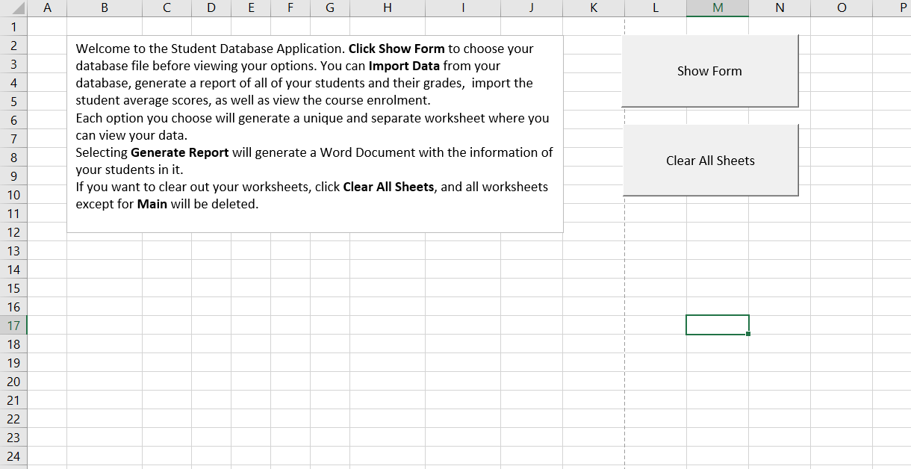

The user is first prompted with the option to Show Form (userform/run the program). Once they click **Show Form**, they will be asked for the file directory via Application.GetOpenFilename. If the file is valid, it will take the user to the page below.

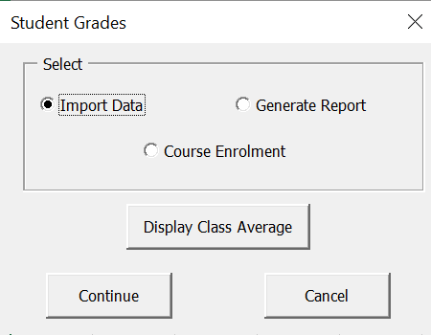

Here, the user is prompted with different options. **Import Data** and **Course Enrolment** will take them to two separate userforms. This will be done when the user clicks **Continue**, and the userform checks to see which JOption is selected. We will cover the **Generate Report** option later. Clicking **Cancel** will unload the form, as well as close the file directory; that way, if the user wants to re-open the database file, an error will not occur. Pressing the **X** button in the top right will call the cancelButton_click sub, which will do the same thing as clicking the **Cancel** button.

Clicking **Import Data** will display this userform, where the user can import certain queries from the database, or import the standard deviation of student grades (this scans through all assignment and exam marks for all courses and calculates the standard deviation via StDev). Whichever option the user selects, the program will create a new unique worksheet and print the data into it. This can be shown by the two images below (**Import Course List** and **Import Student Grades** were clicked).

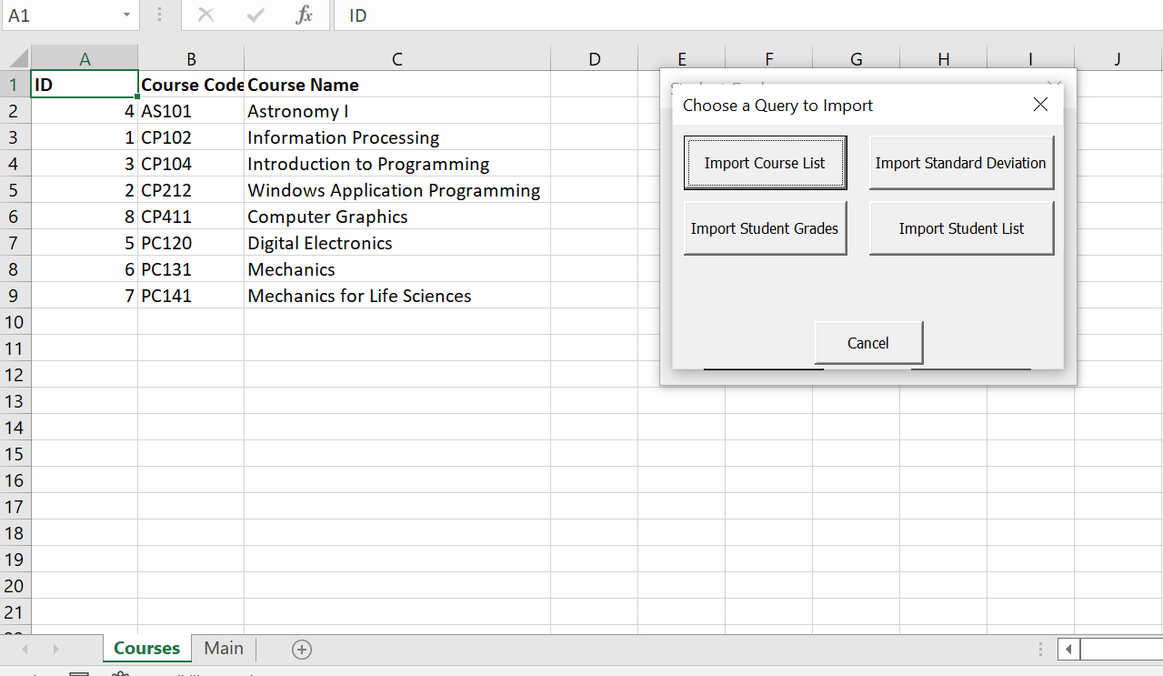

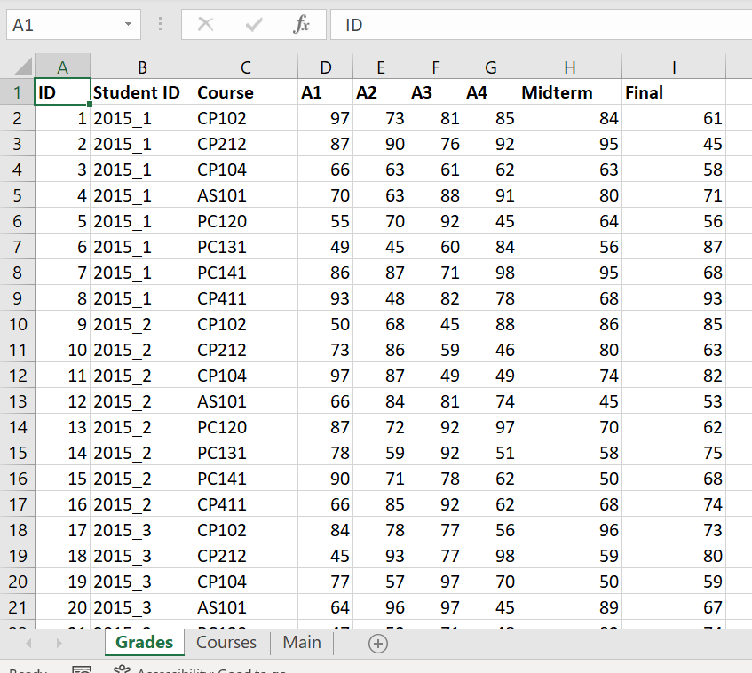

If the user clicks **Continue** while the **Course Enrolment** option is selected, the user will be taken to this userform, where they can choose which course they want to view the student enrolment for. When the user clicks **Continue** with a class selected, the program will create a unique worksheet where it displays all of the students in the specified class. If the user chooses another course and clicks **Continue**, the program will update that same worksheet and change out the students/courses to fit the criteria.

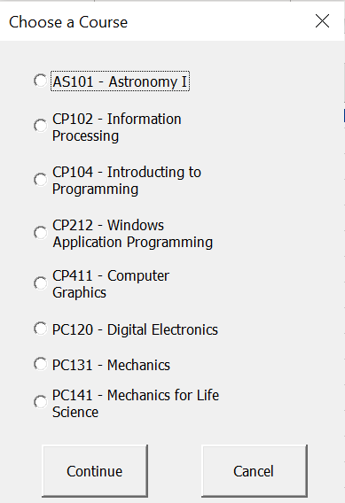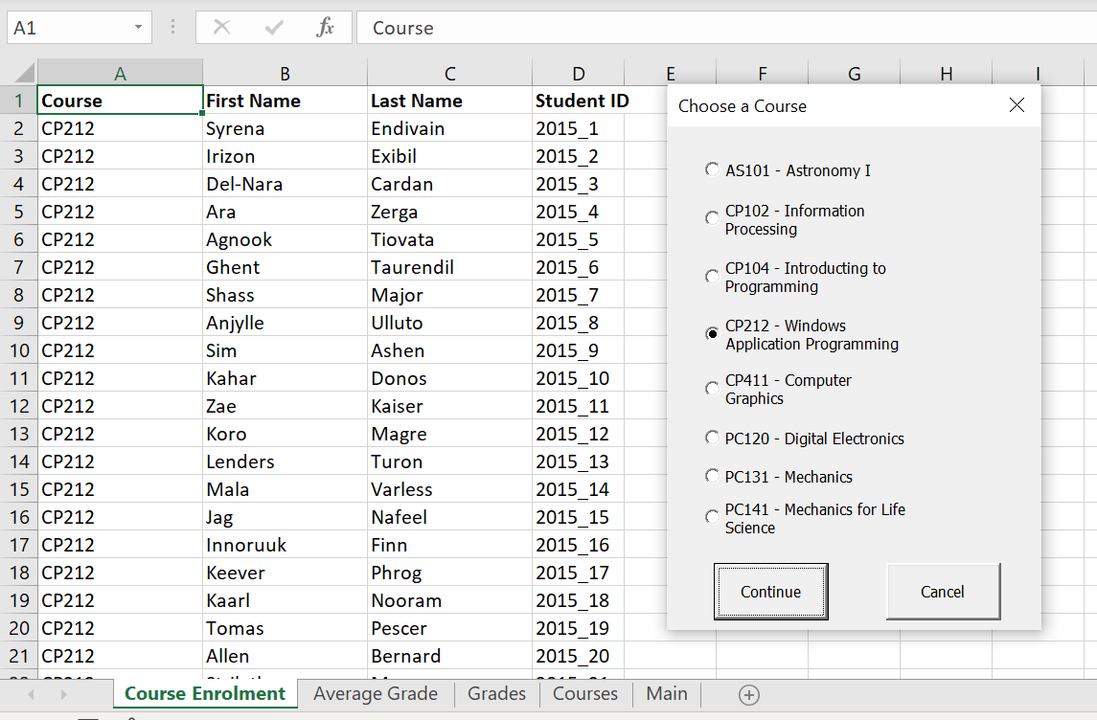

As for how the program creates the criteria and grabs the information:

* Each Class Option will generate a specified **String**
* By implementing multi table linking, I can get information from all of the queries courses.CourseCode with grades.Course, as well as grades.studentID and students.studentID together
* The program then SELECT(s) courses.CourseCode, students.FirstName and LastName, and grades.studentID
  + WHERE the **CourseCode** matches with the specified **String** above (this is the criteria)

Clicking **Display Class Average** will generate a new worksheet, as shown below, where the studentID, query slot ID, assignment/exam grades and overall averages are shown. The weighted average is calculated by multiplying each grade a student gets with their respective weight, before adding them all together. Unfortunately, I could not find a way to create graphs/histograms via VBA, so I was not able to include graphs of the student averages and assignment marks.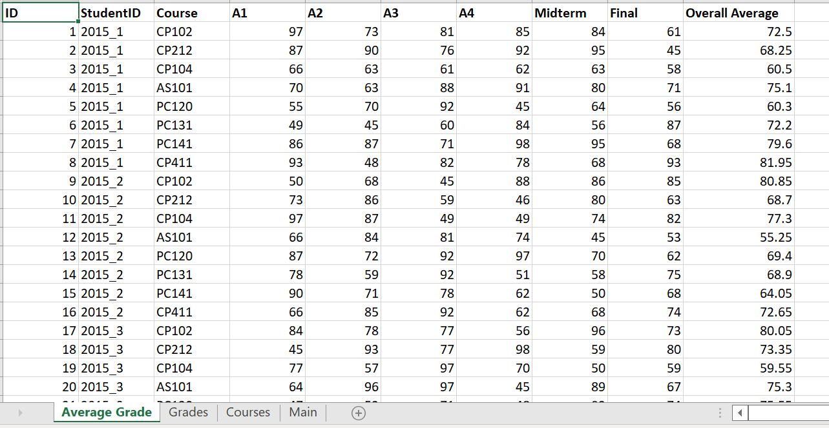

If the user clicks **Continue** and the **Generate Report** option is selected, the program will first run the average grade sub above (opens a worksheet for ID, student ID, student grades and averages). It will then scan through all of the cells and essentially copy/paste it into a word file (by first opening a blank Word Doc and then formatting them into paragraphs). The program will then close the path to the Word Doc; that way, the user can have multiple report documents opened simultaneously. Since the **Display Class Average** function does not generate graphs or histograms, the Word Doc will not have any either, but it still has the code to find all graph objects in the worksheet and copy/paste them into the Word Doc.

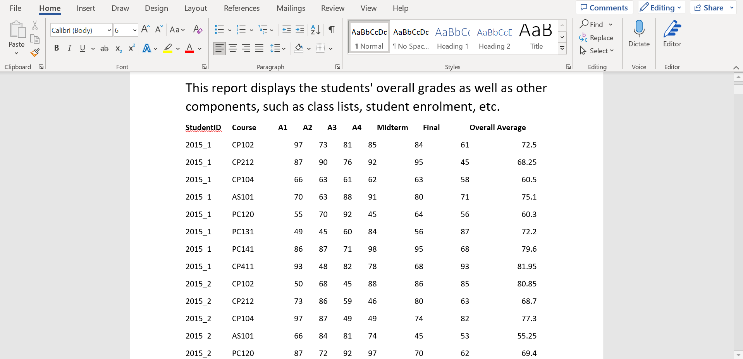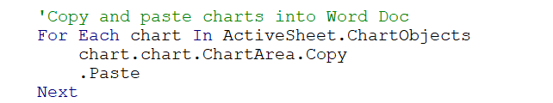

This code above is for copying and pasting all chart objects into the Word Document (which is not present in my example).